1. Show all of the information on the Avengers.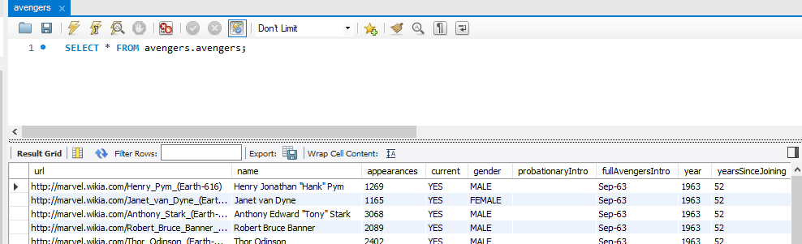
2. Create a new table with information from another super hero group [can be imported from elsewhere or fictitious]. Make sure there is an appropriate header and must be at least 30 rows.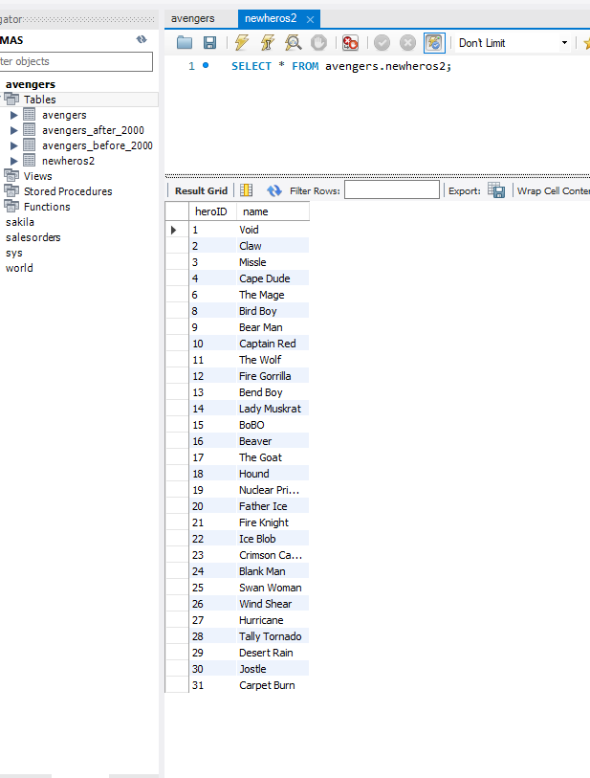
3. Add a column to your new table (the new superheros) for those who are interested in joining the Avengers. Make this be randomly assigned.

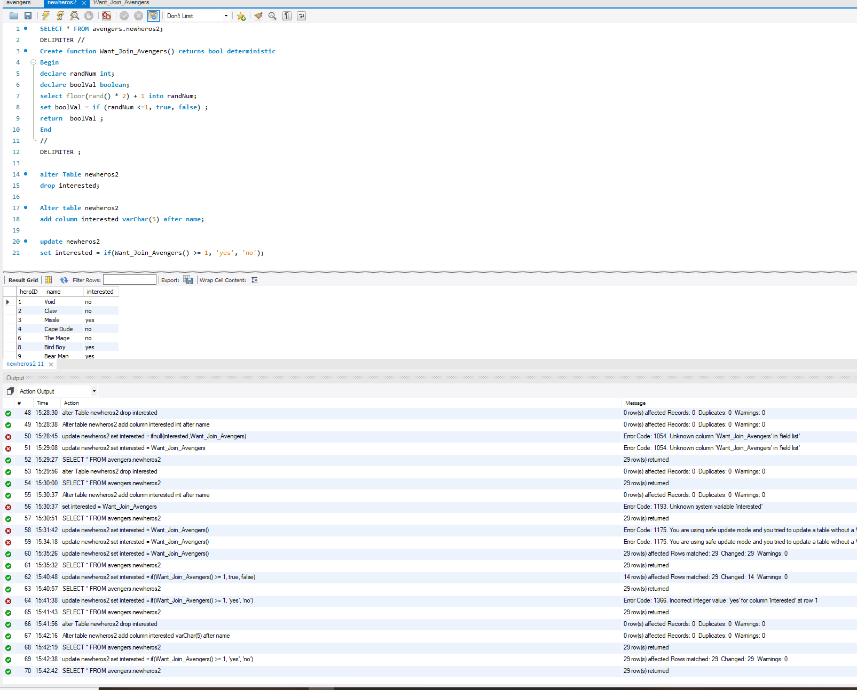

1. Add a column to your new table (the new superheros) for their favorite Avenger (have it randomly choose between Anthony Edward "Tony" Stark, Robert Bruce Banner, & Victor Shade).

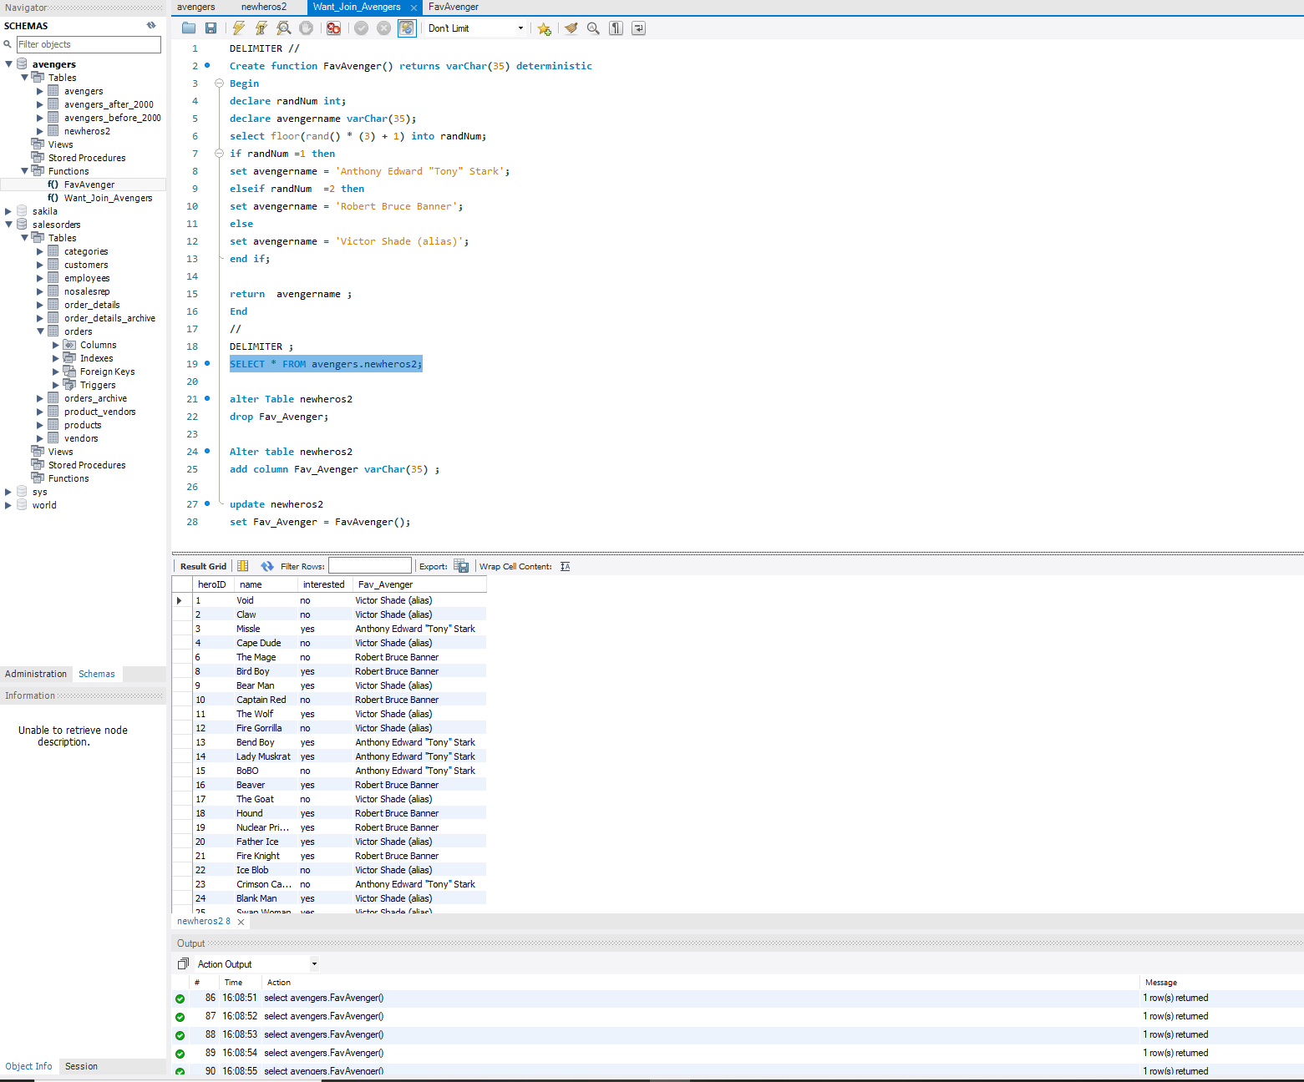

1. Create an association between the two tables for who is interested in joining the Avengers.

***Note: In Screenshot I have merged the joining of the 2 tables into the Create Table.... which I ran before creating the new table called JoinedTable***

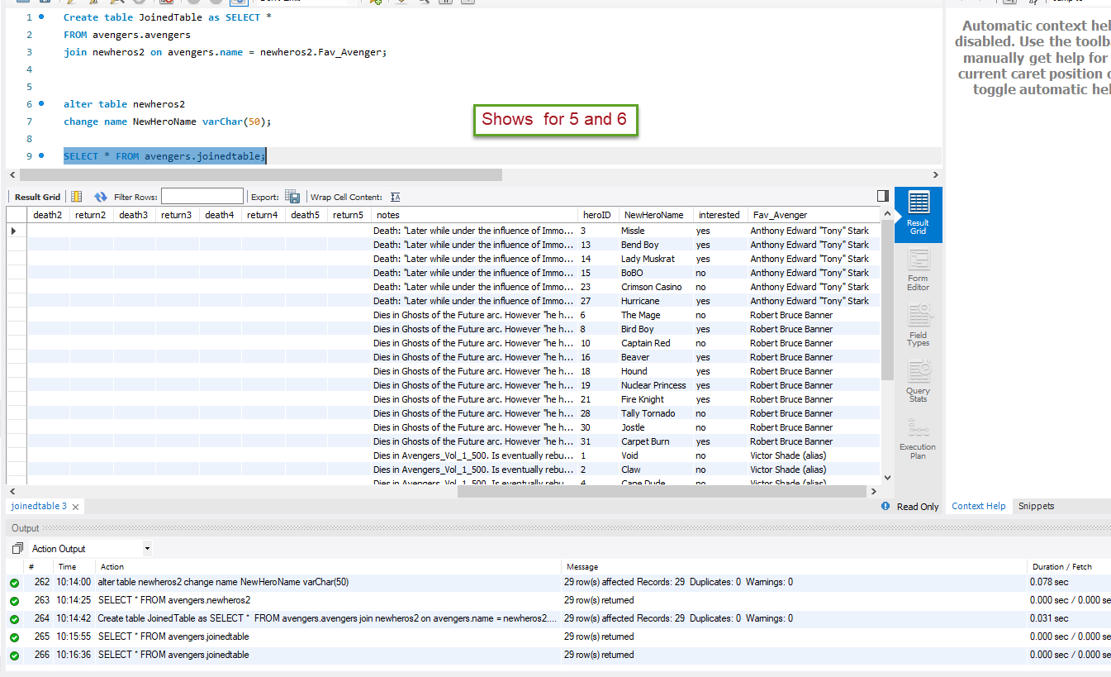

1. Show your association and create a new table for that association.
2. List all Avengers who have more than 1000 appearances in alphabetic order.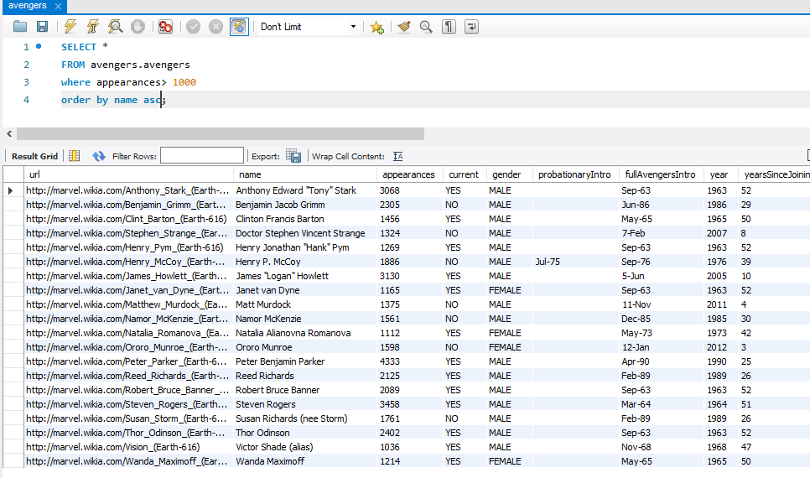
3. What Avengers do not have more than 1000 appearances?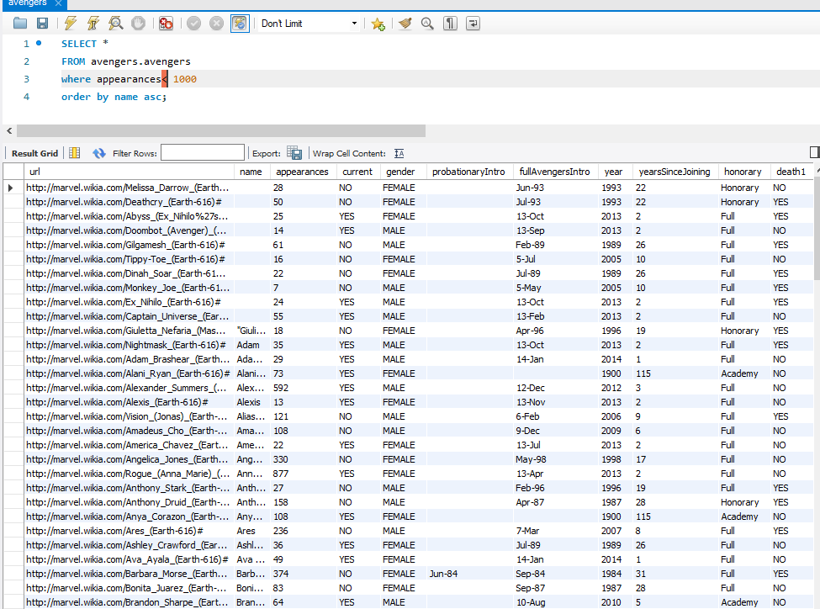
4. Not more than 500?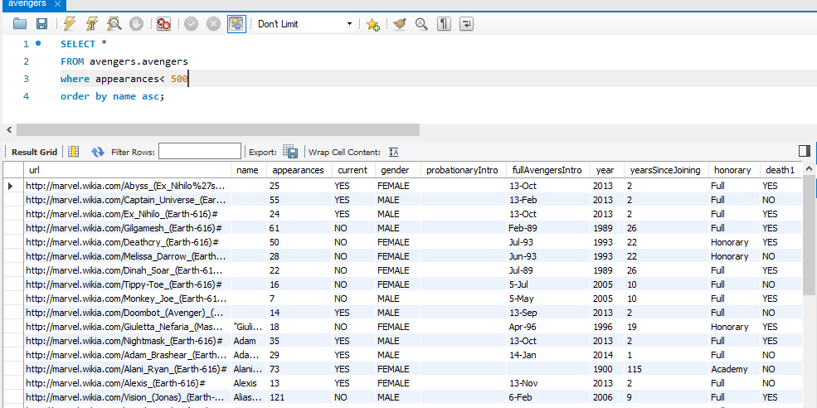
5. Not more than 50?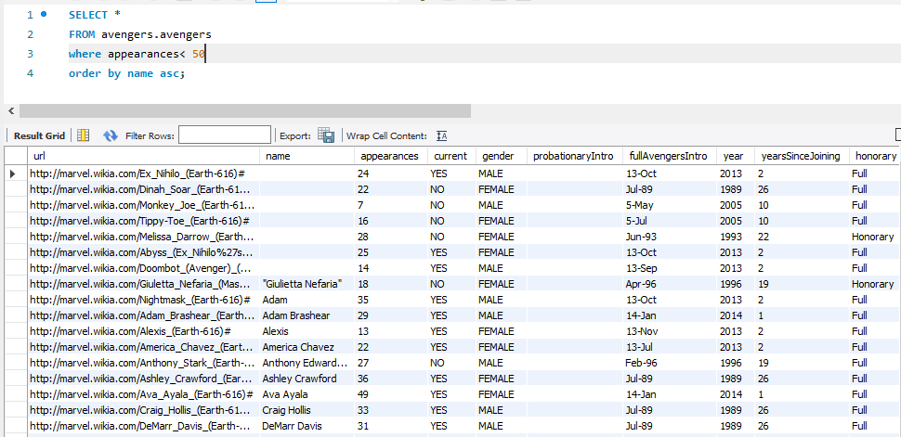
6. Not more than 50 and female?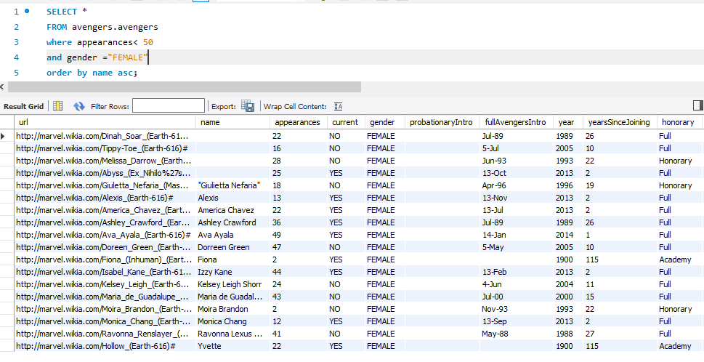
7. More than 150, male, and are full members?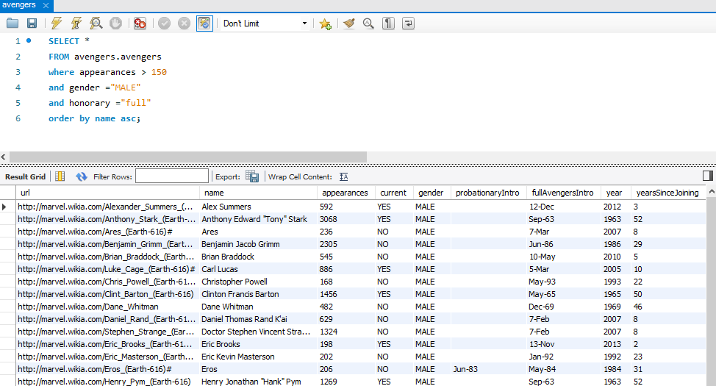
8. Write a function that can add a new superhero to the Avengers if they are interested in becoming an Avenger and if their favorite Avenger is Victor Shade.

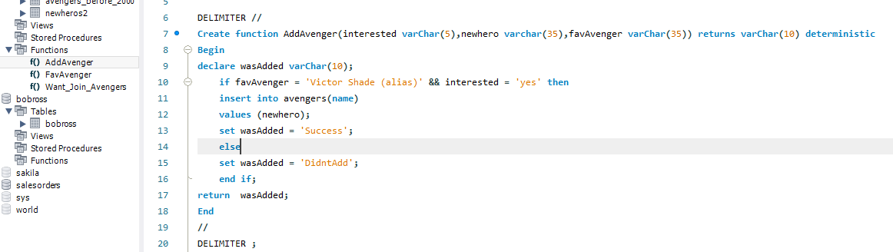

1. Write a function that counts the total amount of records(rows/entries) in a given table.

***Note: I had tried to pass in the value of a table but was unable to get to work....if you want to pass in table name... can you point me in right direction... I was going to try Prepare,Execute and Deallocate statements next but thought I was over thinking.***

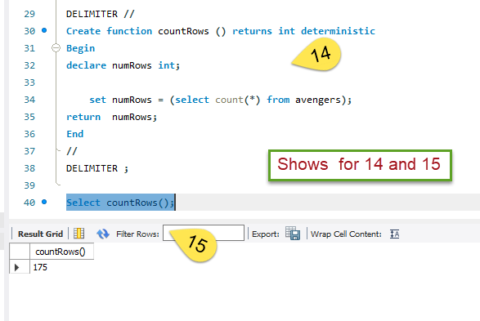

1. Call your totalRecords function on the avengers table. What is the output?
2. There is room for 3 new Avengers so invoke your newMember function 3 times to add 3 new members to the Avengers.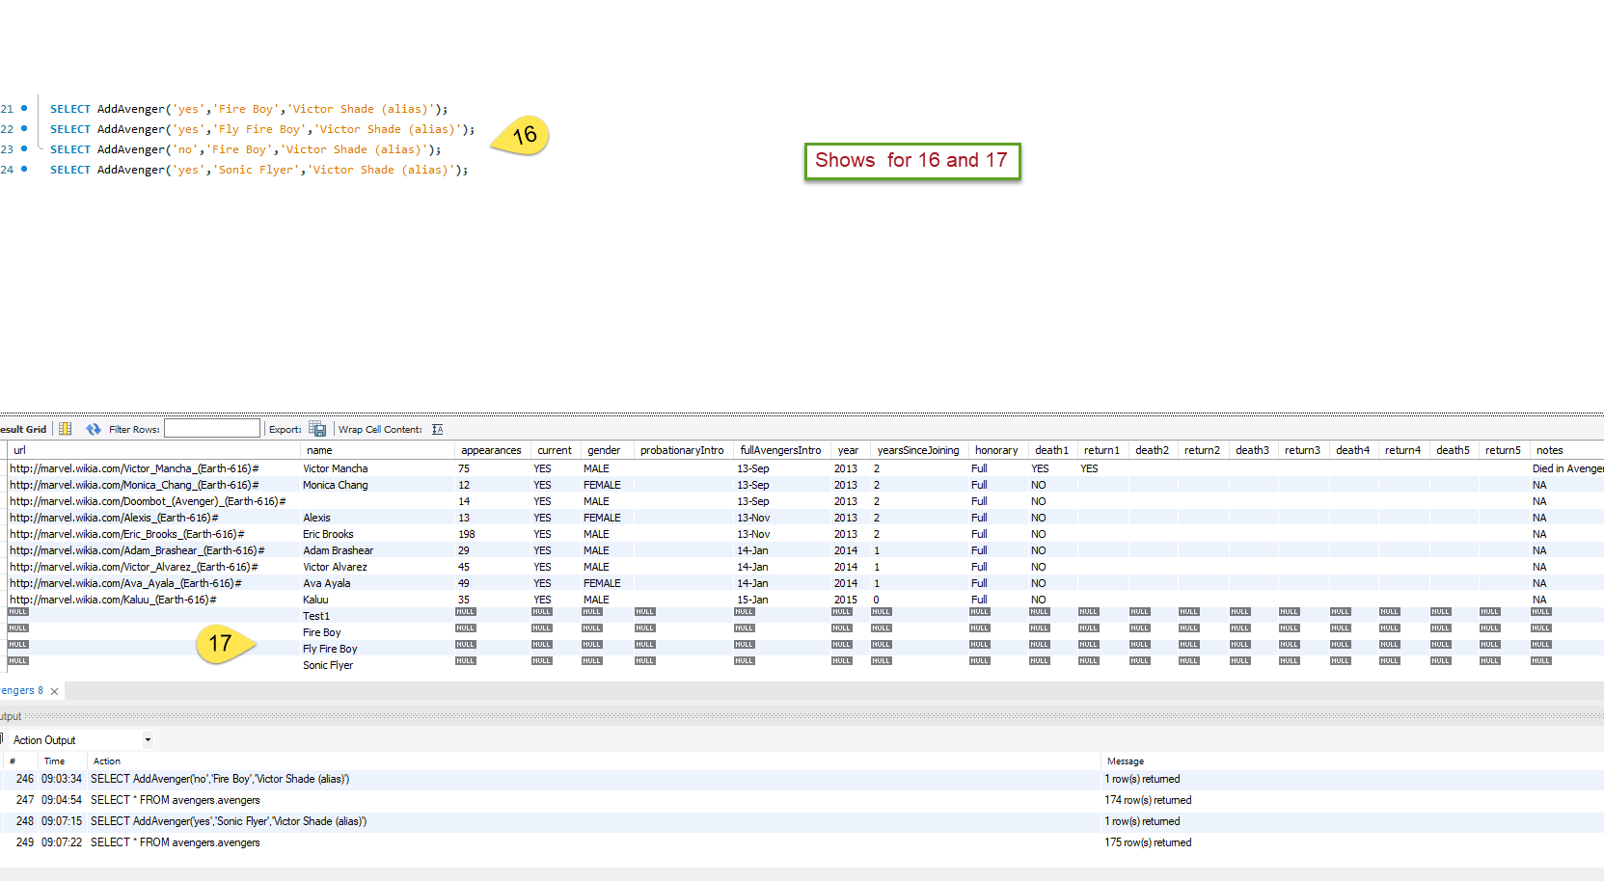
3. Show that the addition of new members was successful.
4. Remove any tables that are not the original avengers table and prove that they have been removed.